****Kennedy Baptist College****

****Year 11 ATAR English 2020****



****Comparing Values, Attitudes and Ideas of Belonging****

****Autobiographies, Memoirs****

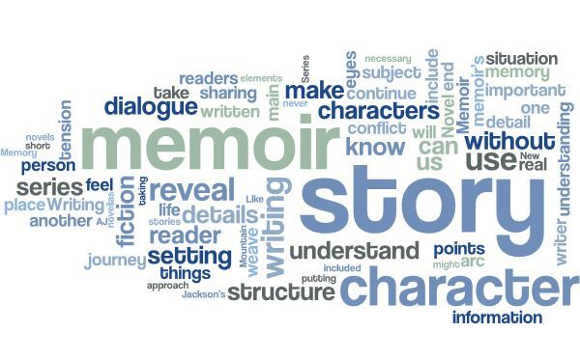

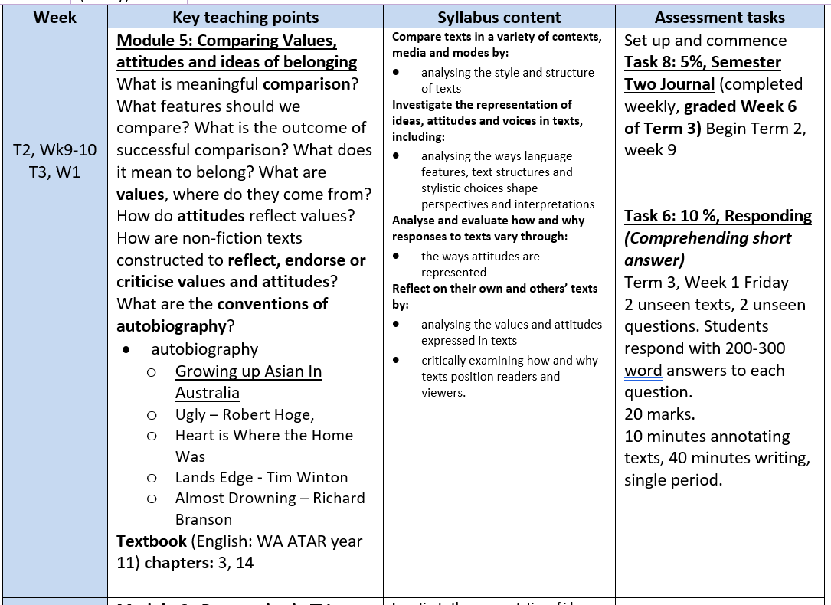Syllabus:

Contents

**VALUES** 3

**ATTITUDES** 4

**TONE** 7

**VOICE** 8

**AUTHORIAL VOICE** 9

**MULTIPLE VOICES** 11

**COMPARISON** 12

**STRUCTURE OF COMPARISON** 13

# **VALUES**

*Values can be thought of as principles of significant importance or worth. At various times in our lives, depending on our personal development and circumstances, we may value principles such as friendship, financial wealth, education, independence, or romantic love. These values guide the way we live our lives and the decisions we make. A value may be defined as something that we hold dear, those things/qualities which we consider to be of worth.*

**Activity:** Below is an extensive list of values.

1. Select 10 of them and rank them according to what you value most to least.

Intelligence, tolerance, power/control, education, independence, recognition from others, etc.

2. What values are promoted in texts we have studied? Write the name title and author of three texts and identify what values are reflected in the text.

a) Ugly – Values: Resilience, forgiveness, optimism and ordinariness.

b) Land’s Edge – Values: Childhood and the restoration of nature and the environment.

c) Anzac Day Speech = Values: Ordinariness, integrity, unity and remembrance.

|  |  |  |  |
| --- | --- | --- | --- |
| A sense of adventure | Exclusivity | Marriage | Rules and standards |
| Acceptance | Fame | Material Possessions | Safety |
| Affection | Freedom | Mateship | Self-acceptance |
| Ambition | Fun | Modesty | Service/ giving back/ community |
| An Occupation | Health | Obedience | Social Status |
| Beauty | Home/family | Order | Spiritual beliefs/faith |
| Childhood | Honesty/Truth | Organisation | Strength |
| Community | Humility | Patriotism | Success |
| Cooperation | Imagination | Physical Strength | Survival |
| Courage | Independence | Popularity | The environment |
| Courtesy | Innocence | Power/Control | Tolerance |
| Creativity | Integrity | Pride | Tradition |
| Diversity | Intelligence | Protection | Trust |
| Education | Justice | Purity | Unity |
| Equality | Love | Recognition from others | Wealth |
| Equity | Loyalty | Respect | Wisdom |

# **ATTITUDES**

Attitudes can be thought of as opinions or viewpoints. Another way of thinking about attitudes is a particular tone, reaction, disposition or feeling toward the subject matter. It is important to understand that just because a text represents particular attitudes, the creator of the text doesn’t necessarily support these themselves. In fact, sometimes characters, people or ideas may be represented in a negative way to emphasise their failings or invite criticism of their values and attitudes.

**Activity:** Although many students can easily identify if an attitude expressed in a text is ‘positive’ or ‘negative’, these terms are really far too vague to offer sufficient analysis. Select some of the specific terms below and decide whether they can be deemed positive, negative or neutral:

*apathetic, contemptuous, jovial, critical, bitter, sincere, concerned, urgent, solemn,  
indifferent, defiant, optimistic, selfish, irresponsible, caring, sceptical, condescending,  
ambitious, considerate, mature, determined, hopeful, regretful, insincere, thoughtless*

|  |  |  |
| --- | --- | --- |
| Positive | Neutral | Negative |
| Jovial, sincere, solemn, optimistic, caring, ambitious, considerate, mature, determined and hopeful. | Apathetic, concerned, urgent and indifferent. | Contemptuous, critical, bitter, defiant, selfish, irresponsible, sceptical, condescending, regretful, insincere and thoughtless. |

2. The decisions you made are really based on a value judgement, guided by what principles you feel are important. Now select one attitude from each category and identify what values underpin these attitudes.

Sincere – Honesty, honour, ethics, genuineness, loyalty, humbleness, nobility and morals.

Apathetic – Neutrality, objectivity, impartiality, non-intervention and avoiding drama.

Condescending – Superiority, supremacy, dominance, distinction, ascendancy and authority.

3. Select an attitude from the list above and speak to others in the class in a tone that reflects the attitude you hold towards a topic of your choice. You will walk around and talk to random class mates for 30 seconds and see if you can guess each other’s attitude.

Practice topic: English exam, BLM protests,

|  |  |  |  |
| --- | --- | --- | --- |
| **Accepting Attitude**  To accept someone regardless of ethnic origin, sexuality, gender etc. To be tolerant. | **Careless attitude**  To display a lack of care or concern about the consequences of one’s actions (foolishness, stupidity) | **Critical Attitude**  Describes when an individual/group who consider the flaws or problems with an event, decision or with other individuals/groups. A person demonstrating a critical attitude will not often express emotion, they are detached and will note the flaws and suggest solutions. | **Domineering Attitude**  To control, govern or rule with superiority. |
| **Apathetic Attitude**  Indifferent due to lack of energy or concern | **Cautious Attitude**  To approach with trepidation and consideration of the risks. | **Cynical Attitude**  Describes when an individual/group displays feelings of disbelief and approaches new ideas, people, groups etc. with caution. | **Fearful attitude**  To be apprehensive, panicky and anticipating terror |
| **Approving Attitude**  Describes when an individual/group who commends or supports an idea, belief, action individual or other group. | **Condescending Attitude**  Describes when an individual/group behaves in a way that implies that they are superior to others. Many people will describe this as being ‘talked down to’. | **Determined Attitude**  Describes when an individual/group who choose to persevere to overcome a problem or obstacle. | **Hostile Attitude**  To displays aggression and anger. Can be displayed through language or through violent acts. |
| **Authoritative Attitude**  To order and command others from a position of authority/power | **Considerate Attitude**  Considers the feelings/concerns/problems of others and displays helpfulness. | **Disapproving Attitude**  Describes when an individual/group who does not approve of an idea, belief, action individual or other group. The individual/group who disapproves may express anger, frustration or annoyance. | **Hypocritical Attitude**  Describes when an individual/group claims to have virtues/morals, but their actions reveal they do not. |
| **Bitter Attitude**  Exhibiting strong animosity as a result of pain or grief | **Courageous Attitude**  Describes when an individual/group do not hesitate to display bravery and heroism even when faced with obstacles. | **Dismissive Attitude**  Describes when an individual/group who demonstrates a lack of care for a problem, group or another individual. This group is aware of the facts, but choose to disregard. | **Humble Attitude**  Displaying modesty and a low estimate of own capabilities. Most societies see humbleness as a positive trait. |

|  |  |  |  |
| --- | --- | --- | --- |
| **Ignorant Attitude**  Describes when an individual/group who are unaware or, choose not make themselves aware and instead make judgement/choices based on a limited understandings. | **Pessimistic Attitude**  Describes when an individual/group displays feelings of hopelessness and negativity. | **Reckless Attitude**  To approach with little concern or consideration of the risks. Could also be described as a care-free attitude. | **Submissive Attitude**  When an individual or group submits to another group/individual’s control. Submissive individuals/groups will accept mistreatment without protest. |
| **Irresponsible Attitude**  To show little care for the consequences of their actions. A person displaying this attitude is often seen as unreliable, immature and requiring guidance. | **Permissive Attitude**  Describes when an individual/group allows and condones particular behaviours. | **Responsible Attitude**  To be accountable to one’s own actions and to have the ability to make rational decisions. A person displaying this attitude is often seen as reliable and dependable |  |
| **Manipulative Attitude**  To control others in subtle ways. | **Prejudiced Attitude**  Describes when an individual/group who demonstrate an unfavourable opinion of other individuals/groups based. This opinion is not based on fact, only on a preconceived idea. | **Self-righteous attitude**  Describes an individual who expresses their (perceived) moral superiority over others. A person who is self-righteous believes that their beliefs and values are morally superior. |  |
| **Menacing attitude**  To intimidate and frighten | **Racist Attitude**  Describes when an individual/group displays prejudiced views based on race/culture or treats individuals/groups differently because of their ethnic identity. It is also racist to judge other cultural groups based on stereotypes. | **Sexist Attitude**  Describes when one gender displays prejudiced views based on sex; behaviour, conditions, or promotes ideas that foster stereotypes of social roles based on sex |  |
| **Optimistic Attitude**  Describes when an individual/group demonstrates hopefulness and positivity even when a situation appears hopeless. | **Rebellious Attitude**  Describes when an individual/group challenges authority and control. | **Smug Attitude**  To express feelings of extreme satisfaction of one’s own situation. Others who are not so fortunate may view this satisfaction as offensive. |  |

**TONE**

You may have noticed that many of the words used to describe attitudes can also be used to  
describe the tone of a text. This is essentially because tone articulates the attitudes the text’s creator expresses towards their subject matter. Here are some examples of the possible ways to simultaneously write about a creator’s attitudes and the tone of their text:

* Helen Garner, writer of *Killing Daniel,* conveys an affronted and disgusted tone and an outraged, furious attitude towards Paul Aiton due to his lack of remorse for his crime. This tone and attitude is emphasised through Garner’s vivid description of his brutish character.
* The attitude of David Suzuki toward the threat of climate change is clearly one of fear and alarm, evidenced in many of his texts including *The Sacred Balance* and his 2006 autobiography.
* Tim Winton’s *Island Home* develops a nostalgic, reverential tone in order to reflect the author’s proud and respectful attitude toward the history and conservation of the natural Australian landscape.

Although values and attitudes are closely related, they are different concepts so it’s important that you don’t treat them as one and the same. To provide a fairly simplistic, but arguably familiar analogy, parents sometimes reprimand their teenagers for expressing a defiant, dismissive attitude when they are asked to clean their room before heading out to a party. In that moment, perhaps the teenager values their social life more than a clean bedroom, which conflicts with the parents’ value of a tidy house. In the same manner, the creators of texts reveal their own attitudes toward others, ideas, behaviours and so on, because of their values. The values are the foundation upon which the attitudes are formed.

So, attitudes can be articulated in either one of two ways:

* As the tone, reaction or feeling expressed toward a subject, including using the conventions of characterisation in fiction texts, such as actions or dialogue
* As an opinion or viewpoint stated or demonstrated by an individual.

**Activity:** Expressing your own attitudes towards an issue or subject

Try to think about how best to express your own attitudes toward a particular issue or subject matter. Fill out the table below in order to experiment with the two main ways of expressing attitudes towards an issue or subject, as detailed above:

|  |  |  |
| --- | --- | --- |
| Issue/subject | Attitude as a tone word/s | Attitude as an opinion/view |
| Example:  Pill testing at music festivals | Example: Optimistic | Example: Pill testing at music festivals is an innovative way to prevent harm to young people. I think it will save many lives. |
| Introduction of a sugar tax | Apathetic. | I don’t really know much on the matter so I don’t have an attitude. |
| Legal prosecution of cyberbullying | Apathetic. | I think it should be stopped, but on the other hand it helps people get over emotional barriers so I guess there should be a balance. |

**VOICE**

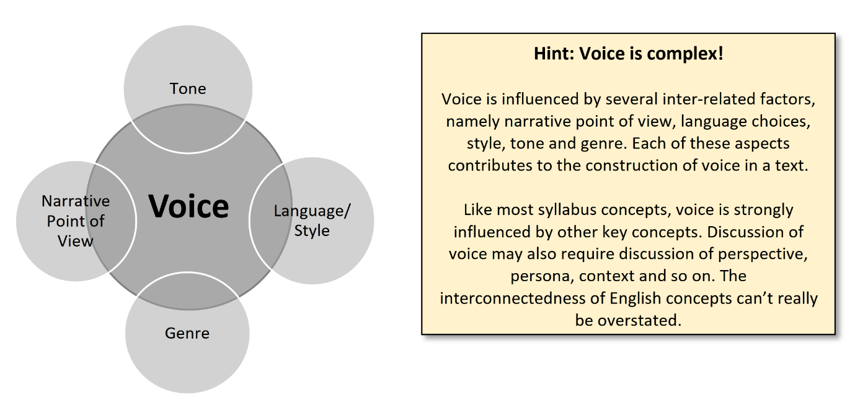The syllabus glossary distinguishes between authorial voice and narrative voice. Regardless of whether analysing the author’s voice (authorial voice) in a fiction or non-fiction text or the narrative voice within fiction texts, references to ‘voice’ should demonstrate an understanding of the persona, role, character or tone adopted by the author in constructing their text. Voice establishes the ‘sound’ of the story or writing and refers to the ‘speaker’ or sense of personality evident. The construction of voice is crucial in: achieving a writer’s purpose, appealing to a specific target audience, reflecting or resisting a particular context and shaping the response of readers. Therefore, voice is one of the most significant aspects of construction, both when writing your own responses and analysing the work of others.

In fiction texts, when trying to accurately identify the voice of a text, it can sometimes be  
easiest to start by recognising narrative point of view in terms of ‘how’ the story is narrated.  
The narrative point of view – which could be first person, second person, third person  
omniscient or third person limited – will determine the degree of intimacy between narrator  
and reader and influence the authenticity and effect of the voice. Also consider the choice of character to function as the narrator. Be mindful that *narrative* point of view is only relevant to a discussion of fictional narratives, when there is a deliberate choice to be made about how the story will be communicated.  
Additionally, the tone of the text is vitally important in any discussion of voice. Tonal words to describe the voice of a text can include the following:

|  |  |  |  |  |  |
| --- | --- | --- | --- | --- | --- |
| *comical* | *formal* | *authoritative* | *nostalgic* | *aggressive* | *hopeful* |
| *conversational* | *causal* | *convincing* | *melancholic* | *accepting* | *peaceful* |
| *informal* | *outraged* | *philosophical* | *humorous* | *sensual* |  |
| *sombre* | *urgent* | *incredulous* | *sarcastic* | *bleak* |  |
| *serious* | *earnest* | *academic* | *impatient* | *frustrated* |  |
| *knowledgeable* | *laconic* | *curt* | *accusatory* | *passive* |  |
| *disgusted* | *apathetic* | *relaxed* | *energetic* | *oppressive* |  |

**Activity:** Select three words from the list above that you are less familiar with, google, and then write down the definition.

The tone and voice of the text is also largely determined by the style of writing or language  
used by the author. It may be shaped by the diction, syntax, punctuation, figurative language and other language conventions or stylistic choices. Therefore, in order to successfully explain how a particular tone of voice is created in a text, you are encouraged to select specific examples of language or stylistic features to support your points.  
These language and stylistic choices will mostly be appropriate to the genre of the text,  
thereby working to consolidate the nature of the text’s voice. For example, narrative writing  
is more likely to use figurative language, while an argumentative essay may use a more formal style in order to create a convincing voice. Try to assess whether the voice works harmoniously with the genre or resists the expectations associated with it. It is recommended that you at least attempt to analyse the point of view, tone and language/style and consider genre when examining voice. These features are closely related to each other.

# ****AUTHORIAL VOICE****

****Authorial Voice:** This is the unique writing style of the author. It's one of the reasons we fall in love with certain writers and want to read everything they've ever written, not just the story that first catches our eye. It's a style that becomes the author's own personal brand. Stephen King has a voice. It doesn't matter whether he's writing a novel or a short story, a male or female character, a horror story or a dystopian thriller, his authorial voice comes through. That's not to say his stories or characters read the same or even sound the same. They don't. But there's a certain style and pace to his writing that we come to expect. His authorial voice.**

**All writers have a voice. Is your voice modern or old-fashioned? Literary or commercial? Does your novel read like a science text or a fast-paced thriller? Is your novel driven by character or plot? What's the balance between the two?**

**Here are some things that I've noticed that can really impact authorial voice:**

****1. Vocabulary and word choice****

**Does the writer use the same words over and over? Does the text read like a verbal test? Is it loquacious? Simple? What kinds of words does the author use to describe the world the book takes place in? Is there slang? Some authors make up their own slang or words, which can really add the voice of a story.**

****2. Ratio of dialogue to descriptive passages****

**A lot of short dialogue sequences will increase the pace, while long descriptive paragraphs slow it down. The balance between dialogue and descriptive passages is an important part of voice. Do you prefer books with lots of descriptions of settings and people? Do you like banter and witty dialogue? Do you have some of each on every page of your manuscript?**

****3. Length of sentences****

**Some authors write in short sentences. Or even sentence fragments. Others have mastered the art of keeping a sentence going, and going; adding clauses and commas to draw out the point. The length of your sentences and how you vary between them is part of your authorial voice. Too many short sentences is jarring. Too many long sentences, and the reader loses interest. Here, there is always a need for balance.**

****4. Use of Interior Monologue****

**A common mistake many writers make is to take the "show, don't tell" school of writing to the extreme, forgetting to put in the character's interior reaction or motivation for doing something. One of the wonderful aspects of reading is that we can literally experience the main characters thoughts and emotions in a way we can't with theater or film. Readers need to experience the character's thoughts, feelings and memories.**

****5. Use of paragraph breaks****

**Are there long paragraphs, or even pages without a paragraph break? Is there a lot of white on the pages. Is there a new paragraph every sentence? Like sentence length, the key is variety of some type or another. Too many long paragraphs in a row and our eyes glaze over. Too many short snappy dialogue quips and we get bored.**

**A standalone sentence for emphasis can create drama.**

**Too many, and you risk losing your reader's trust.**

****6. Use of pacing and plot****

**Voice impacts whether a book moves fast or slow, and how quickly we solve the stories' problems. Generally, dialogue, short sentences and short paragraphs will increase pace. Long paragraphs, with long sentences and lots of description, slow things down. But plot can also be an important part of pacing. Is there tension in every chapter, scene, or page? Do you have quiet moments for internal reaction and character growth? Does the story keep moving forward, or does it get stalled or jump off the rails?**

**\*Do not confuse your authorial voice with character voice. Each character within the story should have their own voice. They shouldn't all sound like the author. The character's voice will reflect their individual background, upbringing, interests, socio-economic status, region, education, intelligence, attitudes, and personality traits. A funny, outgoing main character will have a different voice than a lonely, sad one. A conservative teacher at a posh private school will speak differently from a mechanic with a sixth grade education.**

**You can write all kinds of characters in your story, each with a unique voice, but your authorial voice, the way you choose to tell the story, will probably stay fairly consistent.**

# **MULTIPLE VOICES**

Texts can also include multiple voices which highlight different perspectives. The glossary  
defines the phrase ‘multiple voices’ in the following way:

*Voices in texts: As well as an author’s voice, texts often contain ‘multiple voices’.  
 These are the views, positions, ideas and perspectives of other individuals or  
 groups. It is important to recognise the various voices in a text, how they relate to  
 one another, and how the creator of a text uses these to shape audience response.*

It is important to recognise the distinction between ‘voice’ and ‘multiple voices’ in a text; one is not simply the plural form of the other. While ‘voice’ refers to the authorial or narrative voice in a text and can be explained by an analysis of point of view, language, genre and tone, ‘multiple voices’ relates more directly to the perspectives provided. In her TED Talk, ‘The Danger of a Single Story’, novelist Chimamanda Ngozi Adichie expertly explains the importance of including a wide range of perspectives in written and visual texts in order to ‘give a voice’ to those who are typically silenced or marginalised.

Most narratives will include multiple voices in the form of opposing character perspectives, in order to generate conflict as part of the plot development. The phrase can also be applied  
more literally to texts which provide different narrators or ‘voices’ in order to explain events  
from the perspective of more than one character, as in the case of *The Longest Memory* by  
Fred D’Aguir and *After the First Death* by Robert Cormier.

**COMPARISON**

The widely accepted definition for a ‘comparison’ is a consideration predominantly of the  
similarities, but which may also include the differences, between two or more things – in this case, two or more texts. Alternatively, the word ‘contrast’ is concerned only with identifying elements of difference. You may be required to focus on particular aspects of texts when producing a compare and/or contrast response. These could include (but are not limited to) comparing:  
• the techniques, conventions or language features used in two or more texts  
• the themes, issues, ideas or concepts in two or more texts  
• the reader, viewer or audience response to two or more texts  
• contexts of culture or contexts of situation between two or more texts  
• the stylistic features of two or more texts  
• the text structure of two or more texts  
• the genre of two or more texts  
• the representations in two or more texts  
• the perspectives offered in two or more texts  
• the purposes of two or more texts.

When producing a comparative response, it is important that you include compare and  
contrast terminology very specifically. Observe the compare/contrast words and phrases listed below and complete the related activity:

|  |  |  |  |  |
| --- | --- | --- | --- | --- |
| Likewise | Similarly | In contrast | Comparable to | On the contrary |
| In the same way | However | Unlike | Conversely | Equally |
| As with | Rather | On the other hand | Alternatively | Just as |

**Activity:** Compiling a list of compare and contrast terminology

Use the table below to group the words/phrases above under the headings ‘Compare’ or ‘Contrast’.

|  |  |
| --- | --- |
| **Compare** | **Contrast** |
|  |  |

# **STRUCTURE OF COMPARISON**

In terms of structuring your comparative writing, your approach will depend on the exam  
section, the focus of the question itself and the texts you select or are directed to discuss.  
Approaches A, B and C detailed below are more appropriate for Comprehending Section  
responses, while Approaches D, E and F are better suited to the Responding Section.

